# Data Centric RAD

## Lab 1 MySQL Review

### Part 1

* Get superheroes.sql from Moodle.
* Start Wamp by double-clicking on the Wamp icon on the desktop.
* Then click on the Hidden Icons button, and the Wamp Icon.



* Then click on the MySQL console as shown, and when asked for a password just press ‘Enter’.

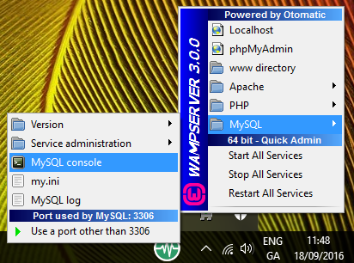

* Import the database into MySQL as follows:
  + Open the Command Prompt
  + In the Command Prompt type:

cd \wamp\bin\mysql\mysql5.6.17\bin

* + Then type:

mysql -u root -p < "***Full Path***\superheroes.sql"

Where ***Full Path*** is the location of the superheroes.sql just downloaded.

* use superheroes;
* List all tables in the database.

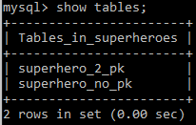

* What is the Primary Key of the superhero_no_PK table?

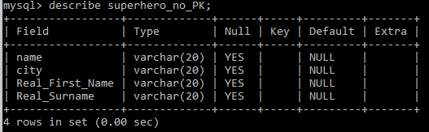

There is no Primary Key in the superhero_no_PK table.

* Show all the rows and columns in the superhero_no_PK table.

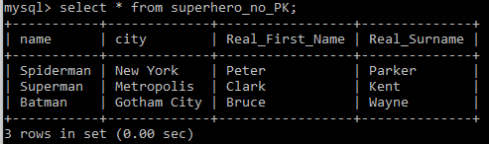

* List all details of all superheroes whose name begins with *S.*

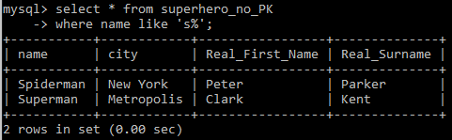

* List all superheroes whose Real Surname contains the letter *n.*

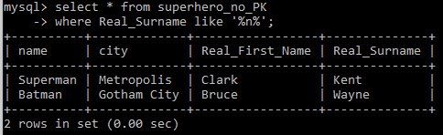

* What is the Primary Key of the superhero_2_PK table?

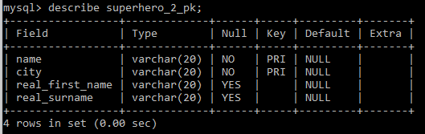

The Primary Key is a Composite Key consisting of name and city.

* List all the details of all superheroes in the superhero_2_pk table who are male (have *man* as part of their superhero name), and who are from Gotham City

The following column names should be displayed:

HERO, city, First Name Alias, Last Name Alias.

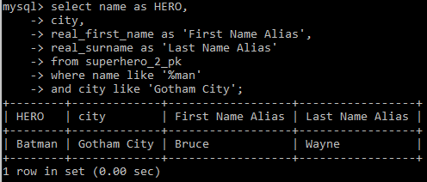

### Part 2

* Get employeesDB100.sql from Learnonline.
* Import it into MySQL using the procedure described in Part 1.
* use employees;
* List all tables in the employees database.

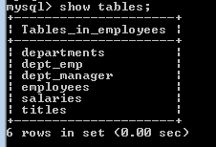

* List all Departments.

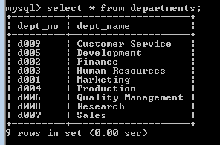

* List **only the name** of the Department d005.

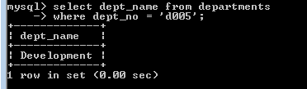

* List all salaries greater than or equal to 101,000, but use an alias called **money** to display the results.

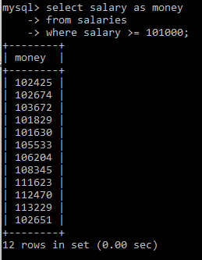

* List all employees who were hired in 1987.

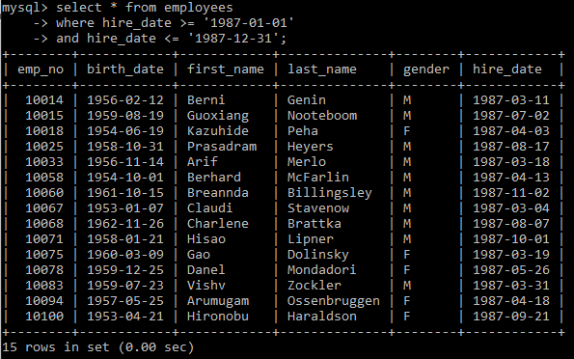

or

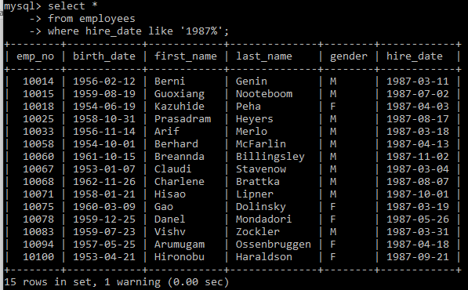

* List all employees who were hired in 1987 but were born in the 1960s or later.

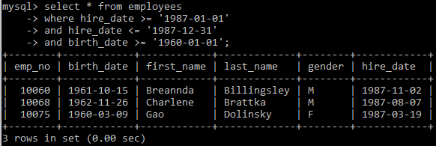

or

